Assignment 4.1

package assignment;

public class acad{

public static void main(String[] args) {

int a;

int b;

int c;

a = 14;

b = 11;

c = a + b;

System.out.println("sum is : " + c );

}

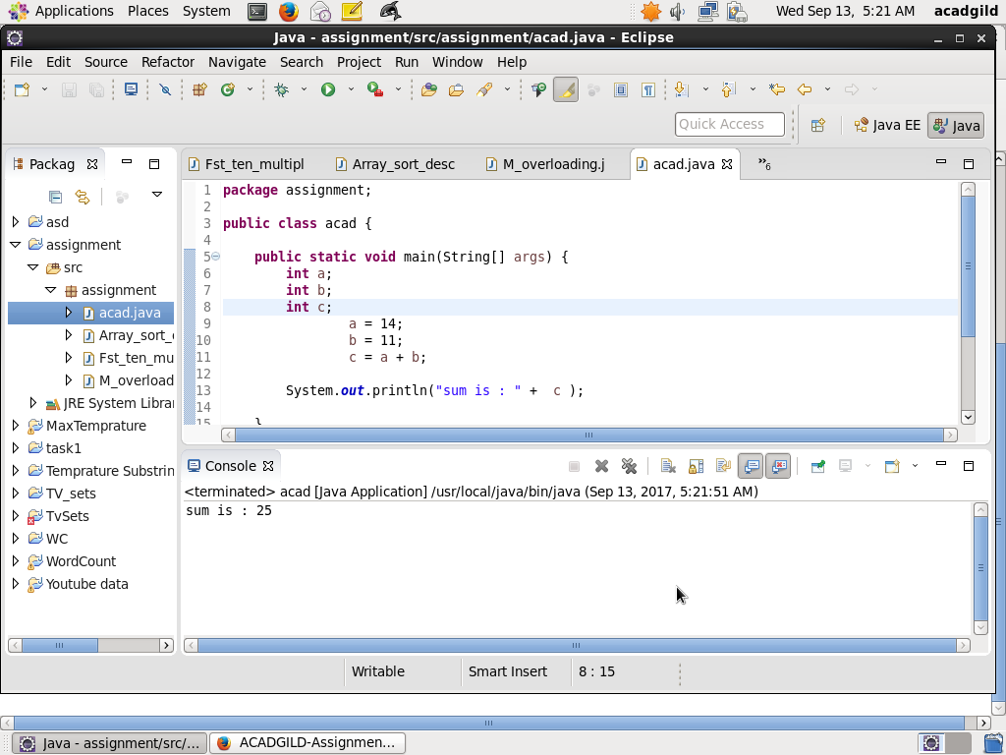

package assignment;

import java.util.Scanner;

public class Acad_runtime {

public static void main(String[] args) {

int c;

@SuppressWarnings("resource")

Scanner scan = new Scanner(System.in);

System.out.println("Enter value for a : " );

int a = scan.nextInt();

System.out.println("Enter value for b : " );

int b = scan.nextInt();

c = a + b;

System.out.println("sum of " + a + " and " + b + " is : " + c );

}}

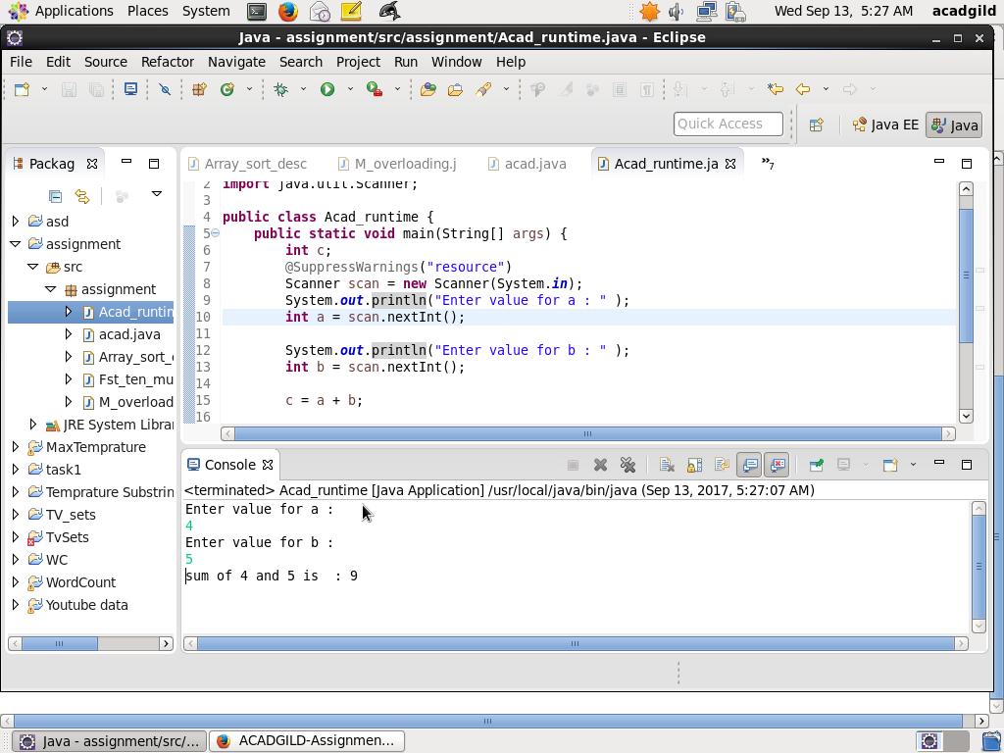

3.

package assignment;

import java.util.Scanner;

public class Stdin_sum {

private static int Sum(int x , int y){

return(x + y);

}

public static void main(String[] args) {

@SuppressWarnings("resource")

Scanner scan = new Scanner(System.in);

System.out.println("Enter value for a : " );

int a = scan.nextInt();

System.out.println("Enter value for b : " );

int b = scan.nextInt();

System.out.println("First Number is " + a );

System.out.println("Second Number is " + b );

System.out.println("Sum is " + Sum(a,b));

}}

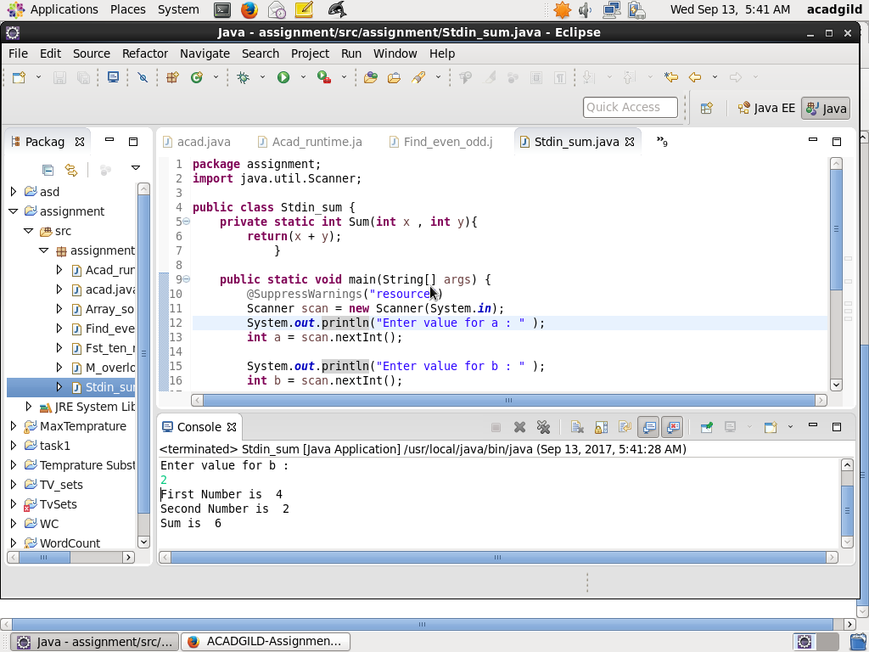

4.

package assignment;

import java.util.Scanner;

public class Find_even_odd {

public static void main(String[] args)

{

@SuppressWarnings("resource")

Scanner scan = new Scanner(System.in);

System.out.println("Enter value for a : " );

int a = scan.nextInt();

int o = 0;

int e =0;

System.out.println("Enter value for b : " );

int b = scan.nextInt();

int [] EvenNumber = new int[b];

int [] OddNumber = new int[b];

for (int i = a;i< b + 1;i ++)

{

if ((i % 2) == 0)

{

EvenNumber[e] = i;

System.out.println("EVEN :"+EvenNumber[e]);

e = e + 1;

}

else

{

OddNumber[o] = i;

System.out.println("ODD :"+i);

o = o + 1;

}

}

System.out.println("LIST OF EVEN NUMBERS BETWEEN " + a + " AND " + b + ":");

for (e = 0;e <EvenNumber.length;e++)

{

System.out.println(EvenNumber[e]);

}

System.out.println("LIST OF ODD NUMBERS BETWEEN " + a + " AND " + b + ":");

for (o = 0;o <OddNumber.length;o++)

{

System.out.println(OddNumber[o]);

}

}

}

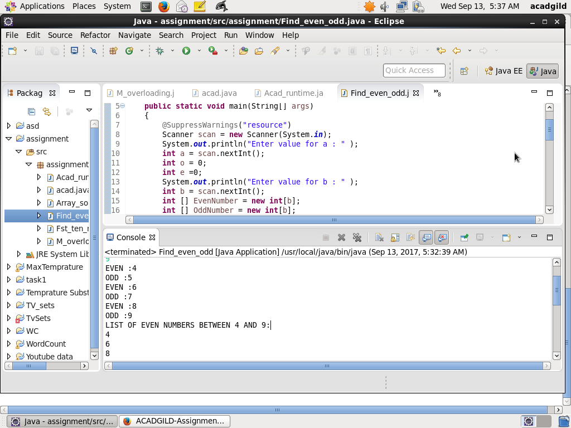

5.

package assignment;

import java.util.Scanner;

public class Fst_ten_multiple {

public static void main(String[] args) {

@SuppressWarnings("resource")

Scanner scan = new Scanner(System.in);

System.out.println("Enter value for which multiple of 10 has to be obtained : " );

int a = scan.nextInt();

System.out.println("Input : "+ a);

System.out.println("Output ");

for (int i = 1;i < 11 ;i ++){

System.out.println( a + " * " + i+ " = " + a*i);

}

}

}

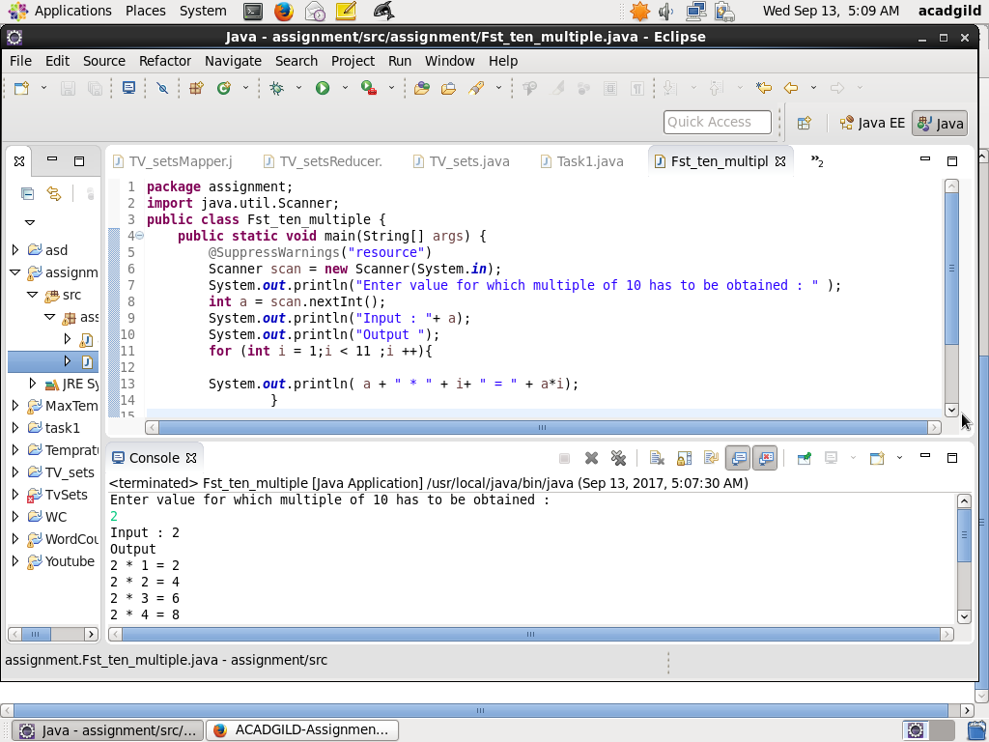6.

package assignment;

class sum1

{

public int Sum1(int x,int y)

{

return(x+y);

}

public int Sum1(int x,int y,int z)

{

return(x+y+z);

}

}

public class M_overloading {

public static void main(String[] args) {

sum1 obj = new sum1();

System.out.println(obj.Sum1(12,4));

System.out.println(obj.Sum1(1,23,34));

}

}

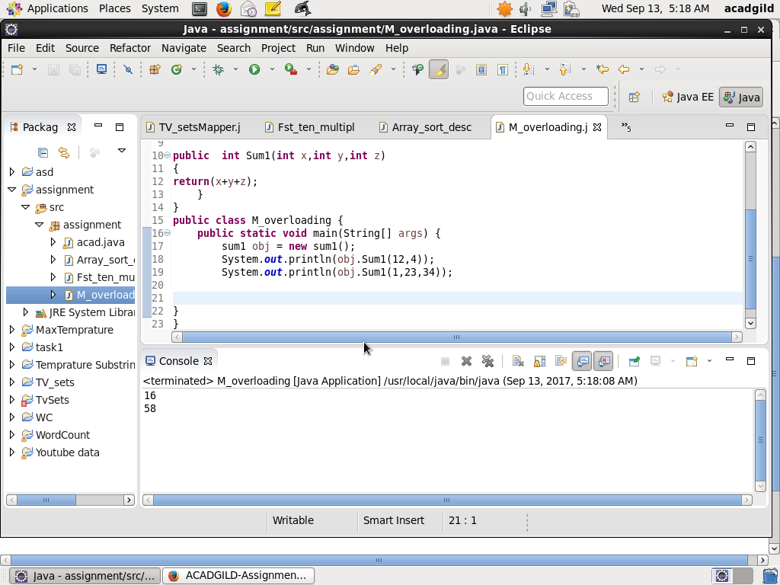

7.

Yes, we can Overload a method with the same return type , that can be seen by the above program.

8.

package assignment;

import java.util.Scanner;

public class Array_sort_desc {

public static void main(String[] args) {

int n,temp;

@SuppressWarnings("resource")

Scanner scan = new Scanner(System.in);

System.out.println("Enter the no of elements in array");

n = scan.nextInt();

int a [] = new int[n];

System.out.println("Enter all the elements :");

for (int i =0;i < n; i++)

{

a[i] = scan.nextInt();

}

for (int i =0 ;i<n;i++)

{

for (int j = i + 1;j < n; j++)

{

if ( a[i] < a[j])

{

temp = a[i];

a[i] = a[j];

a[j] = temp; }

}}

System.out.println("Descending Order :");

for (int i = 0; i< n - 1; i++)

{

System.out.println(a[i] + ",");

}

System.out.println(a[n-1]);

}

}

